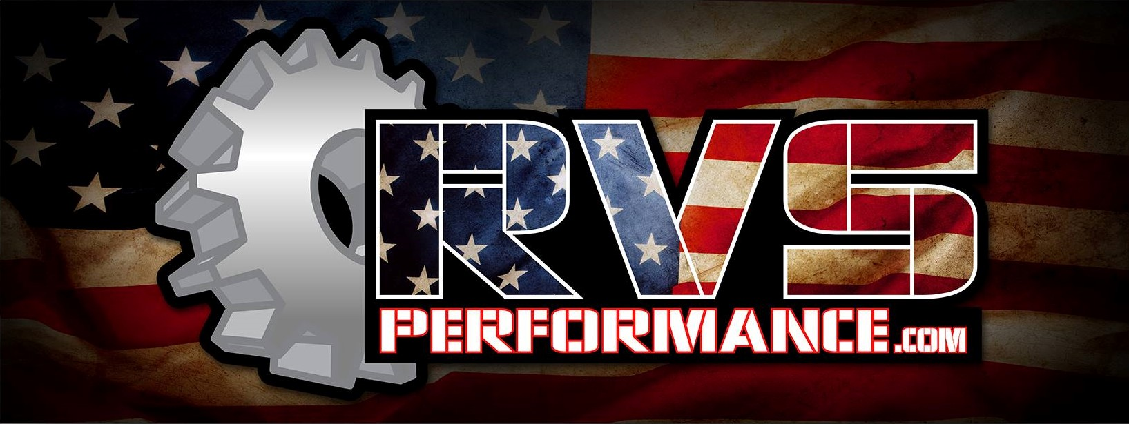
Dynojet PV4 Instructions:
Thank you for your purchase of Dynojet Power Vision 4 from RVS Performance!
Follow the instructions supplied in the box from Dynojet to download their app and get your account set up. Once you have that done and your machine info uploaded press the share button on the top right corner of the screen. (see picture below).
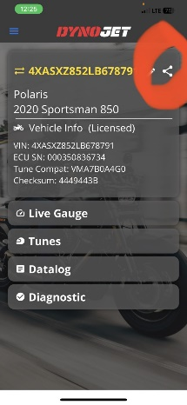
Share your information from the email account that you set up your Dynojet account with to:
ryan@rvsperformance.com
***Please also include your order number if you have one along with year and model of machine in this email. In addition, what exhaust and intake mods you are running***
It typically takes 2-3 hours during business hours depending on the volume of orders we have. Files sent after 4pm Friday may not come back till Monday morning.
You will receive an email back from Ryan once your tune files are uploaded to the cloud. Reopen your app and your new tunes should be there.
If you have any further questions, please feel free to call us at 651-500-0657 between the hours of 9am and 5pm (CST), Monday -Friday.

