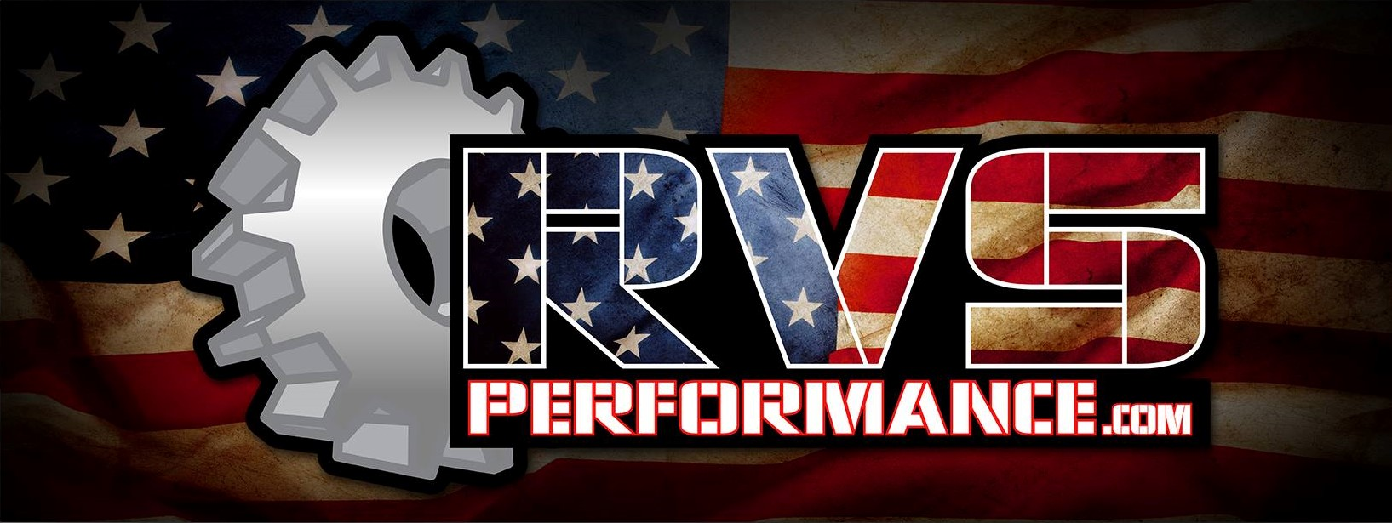
Dynojet PV3 Instructions:
Thank you for your purchase of a Polaris / Indian Dynojet Power Vision 3 from RVS Performance!
When you receive your unit, you will find 2 separate cords packaged with your unit. You will need to plug your unit into your diagnostic port on your machine, using the cord provided.
If not prompted on initial power up to read the ecu, select “Vehicle Tools”, and then “Read ECM”. This process will take approximately 15 minutes to complete.
Once you have your stock file downloaded to the unit, attach the unit to your PC (USB Port) using the second cord provided. Upon doing this, you will have a window pop-up on your screen, listing all of the files contained within your Power vision unit.
Attach the .STK file, along with the PV_INFO file to an email and send them to:
ryan@rvsperformance.com
***Please also include your invoice number if you have one along with year and model of machine in this email. In addition, what exhaust and intake mods you are running***
Sit down, put your feet up, and drink a beer (or other refreshment of your choice) while you wait for Ryan to work his magic and get your file back to you. Please limit your intake to a safe level so as not to be drunk when testing your new tune. It typically takes 2-3 hours during business hours depending on the volume of orders we have. Files sent after 4pm Friday may not come back till Monday morning.
Once you have received your file, you will need to save it to your computer, and copy it to the Power vision unit.
Plug the Power vision unit into your diagnostic port on your machine, select the “Flash Tune” option, scroll down to the file you wish to install, and then select “Flash Tune”, select the new .Djt file from RVS and confirm. Follow the prompts on the screen. This process will take 5-7 minutes to complete.
If you have any further questions, please feel free to call us at 651-500-0657 between the hours of 9am and 5pm (CST), Monday -Friday.

