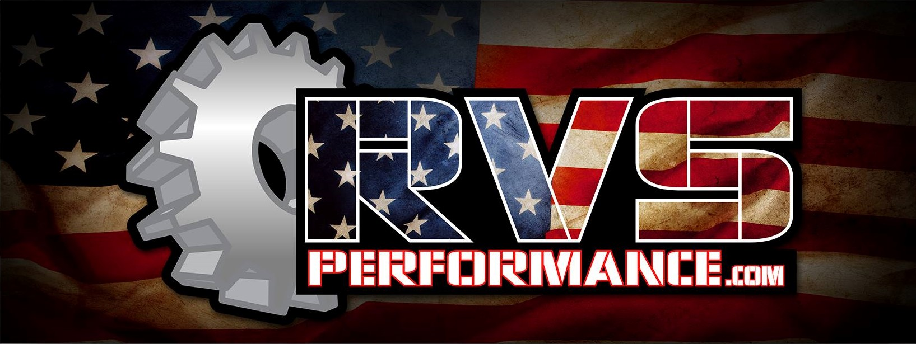
Dynojet PV3 Instructions:
Thank you for your purchase of a CanAm matched Dynojet Power Vision 3 from RVS Performance!
When you receive your unit, you will find 2 separate cords packaged with your unit. You will need to plug your unit into your diagnostic port on your machine, using the cord provided.
Follow the prompts on the screen to check for compatible files and it will create a data file we need automatically. You will not find any compatible files. Once completed, turn the machine off and remove the tuner from it. Attach the unit to your PC (USB Port) using the second cord provided. Upon doing this, you will have a window pop-up on your screen, listing all of the files contained within your Power vision unit.
Create a new email addressed to Ryan@RVSperformance.com and attach the PV_INFO file to it. Once attached and the info below is included, send it.
***Please also include your invoice number if you have one along with year and model of machine in this email. In addition, what exhaust and intake mods you are running***
It typically takes 2-3 hours depending on the volume of orders we have to receive your tune file back. Files sent after 4pm Friday may not come back till Monday morning.
Once you have received your file, you will need to save it to your computer, and copy it to the Power vision unit.
Plug the Power vision unit into your diagnostic port on your machine, select the “Flash Tune” option, scroll down to the file you wish to install, and then select “Flash Tune”, select the new .Djt file from RVS and confirm. Follow the prompts on the screen. This process will take 5-7 minutes to complete.
If you have any further questions, please feel free to call us at 877-538-5803 between the hours of 9am and 5pm (CST), Monday -Friday.

